**Professional Background:**

NAME









**Excel, Google Sheet**

**PHP/SQL/OOP**

**SOFTWARE**

PYTHON DEV./ DATA ANALYST / ML / I.T. PERSONNEL

**LAN Networking & Administration**

**Home Address**

Nigeria.

**E-mail**

checkmate.olu@gmail.com

**Phone**

+2348167002104

**CONTACT**



**ABOUT ME**

I have M.Sc. in Information Technology and B.Tech. in Computer Engineering, just concluded Machine Learning with AWS training from Udacity Scholarship, Rounding off ENTRY LEVEL Data Analytics training and well-groomed in Python Coding. I am currently working at CECE Technologies Solutions that major in Information Technology with expertise in Coding, Hardware training and other I.T. Training. We have reputable clients across Lagos and some other parts of the country. What you can’t take away from me is my Eagerness and Readiness to learn new things. Thing

**EDUCATION**

**ENTRY LEVEL – DATA ANALYSIS with Google Sheets and Tableau: (**2021)

**UDACITY SCHOLARSHIP - MACHINE LEARNING WITH AWS:** (2021)

IT LEARNING ACADEMY MALAYSIA: Computer Vision with Python (2021)

IT LEARNING ACADEMY MALAYSIA: Automation with Python (2021)

IT LEARNING ACADEMY MALAYSIA:Getting Started with Python2021

**Digital Literacy Conference:** Coding with python Certificate (2021)

**National Open University of Nigeria** (2017)

**Qualification:** M.Sc. Information Technology

**LADOKE AKINTOLA University of TechnologyOgbomoso**

**Qualification:** B.Tech. Computer Engineering ( 2001-2006)

**University Council of Jamaica:** O’ Level Equivalence Assessment

**Obokun High School, Nigeria:** Secondary School Certificate

**SKILLS**

**DATA ANALYSIS, ML WITH AWS…**

**PYTHON AUTOMATION & CP. VISION**

**Software Testing**

**Table of Content**

Professional Background

**Tableau/ AWS…**

1

**PYTHON, HTML, CSS**

**Table of Contents:**

**Professional Background 1**

**Table of Contents 2**

**Udemy Project Description 3**

**The Problem 5**

**Design 6**

**Findings 7**

Figure 1: Udemy_Business_Course Chart 7

Figure 2: Udemy_Design_Course Chart 8

Figure 3: Udemy_Music_Course Chart 9

Figure 4: Udemy_Web_Development_Course Chart 10

Figure 5: SUM of Num Subscriber/ Subject 11

Figure 6: AVERAGE of Num Subscriber/ Subject 12

Table 1: Summary Table for Subjects / Sum Num_Subscribers 11

Table 2: Summary Table for Subject / Average Num_Subscribers 12

**Analysis 13**

**Conclusion 14**

**[World Population by Year] Project Description 15**

**Data Design 16**

**Findings 17**

**Data Analysis 19**

**Conclusion 20**

**Appendix 21**

**Udemy Project Description:**

You’re a Data Analyst working for the education tech company Udemy. You have been asked by your manager, Head of Curriculum at Udemy, to present the data on course revenue, and you have been provided with data on courses from different topics to understand where opportunities to increase revenue may lie, and track the performance of courses.

Your manager has suggested encouraging Web Development courses to charge more, because she believes that these are the most popular courses. She needs to send a report to the CEO in the next three weeks on how they will increase their next quarter earnings.

Getting the data_sheets available from this project titled:

- Data_Sheets_Udemy_ Courses_Business

- Data_Sheets_Udemy_ Courses_Design

­- Data_Sheets_Udemy_ Courses_Music

­- Data_Sheets_Udemy_ Courses_Web_Development.

I re-titled the project into Udemy_Courses_Olu, so as to depict my name for personalization and the Data sheet involved as below:

- Udemy_Courses_Business_Olu

- Udemy_Courses_Design_Olu

­- Udemy_Courses_Music_Olu

­- Udemy_Courses_Web_Development_Olu

Now working with the data supplied on the Google sheets for each data sheet, I was able to remove some notable topics repetition with the help of “Remove Duplicate” tools. For instance, under the following Column Headings like: Level and Subject, Beginner level, expert level, all level, graphic design, Graphic designer, Web Development, etc. As one of the major tasks to be carried out in the project were all deleted to the barest minimum in Udemy_Courses_Olu project.

In module 4 under Data visualization, we were told to plot the following:

• Total number of subscribers for each subject (Pie Chart)

• Average number of subscribers for each subject (Bar Chart)

• Average cost per subject at each level (Bar Chart)

• Average content duration for each subject (Bar Chart)

• Average rating per subject for each level (Column Chart)

• Any other data that you feel will be important to include in your analysis.

From the data, instead of using subject for the task above, I switched to “Course_title” since I realized most of the subject in each Data cell has been deleted off due to the task “Remove Duplicate” in Google sheets.

I plot the chart and they were great for both ‘SUM’ and ‘AVERAGE’ task requested for. Great observations from the graph made us to see the courses that are of more important than others and courses that its Num_Subscription have to increase.

**The Problem:**

From the project topic, we can depict that Udemy are experiencing low patronage and its reducing company’s revenue. As a result of this, the business problem can be mentioned below as:

**“Recognising revenue increase opportunities in popular courses.”**

Three weeks will be enough to complete this project and get a good narrative to back it up.

The following data should be collected and look into for this project:

Course title: Title of the courses available under each Subject.

Subject: The list of courses being offered by Udemy (Business, Design, Music and Web Development).

Num subscribers: No of people that subscribed for the courses

Content Duration: The time taken for the course to be completed.

Free Courses or Paid courses: To find out whether the course is free or paid for.

Price: Amount being paid for the courses

Level: Whether Beginner level, Expert level, Intermediate level or All levels.

I will ask the following question in order to understand the business problem well:

* Why is the revenue at Udemy decreasing?
* Why are people not subscribing to Udemy courses?
* Why do we charge less for the popular courses that we have?

**Design:**

Removing duplicates trimming white spaces and removing blank cells have been carried out on the Udemy_Courses_Olu project, though other Data cleaning processes like clean up suggestion and column stats were also looked into on each data sheet.

Excel and Tableau are the two visualization tools that were used for this particular project; they show all the hidden insight and help our findings and observation on this particular project.

**Findings:**

After plotting the chart that was instructed to plot using Excel and Tableau in the format below:

• Total number of subscribers for each subject (Pie Chart)

• Average number of subscribers for each subject (Bar Chart)

• Average cost per subject at each level (Bar Chart)

• Average content duration for each subject (Bar Chart)

• Average rating per subject for each level (Column Chart)

• Any other data that you feel will be important to include in your analysis.

Some of the Insight and Observation from the chart were shown below:

**Figure 1:** Udemy_Business_Course Chart:

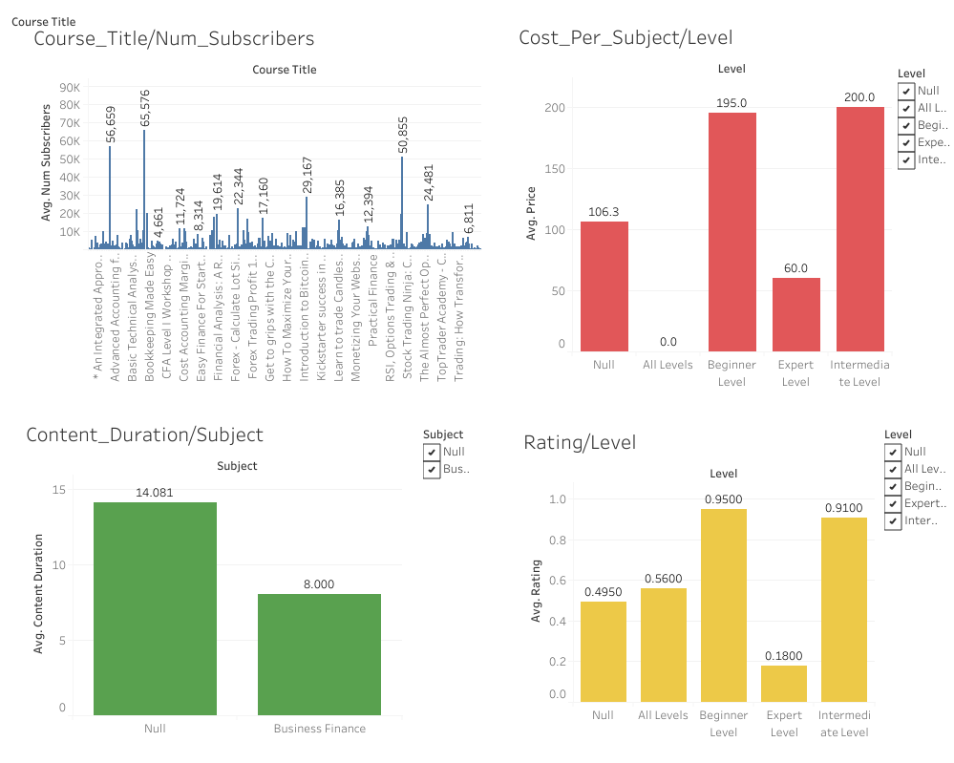

The following insight were derived and observed from the Udemy_Business_Courses Chart above:

* The average Num Subscriber is around 65,576 in numbers
* Beginner level and Intermediate level have the highest figures when considering Cost Per Subject (Price).
* When considering average rating per subject for each level, beginner level remains the highest follow by intermediate level.
* For Business Subjects, Content Duration is 8000.

**Figure 2:** Udemy_Design_Course Chart:

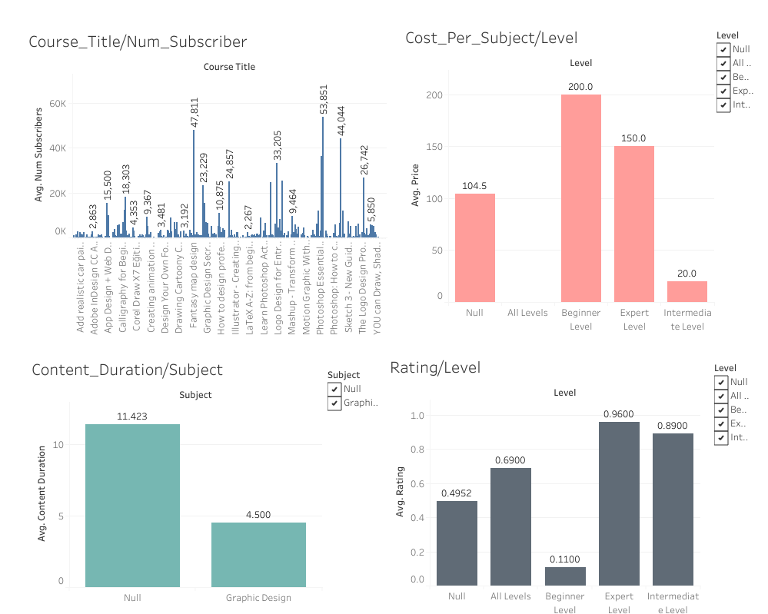

The following insight were derived and observed from the Udemy_Design_Courses Chart above:

* The average Num Subscriber is around 53,851 in numbers
* Beginner level has the highest figures when considering Cost Per Subject (Price).
* When considering average rating per subject for each level, expert level has the highest.
* For Design Subjects, Average Content Duration is 4500.

**Figure 3:** Udemy_Music_Course Chart:

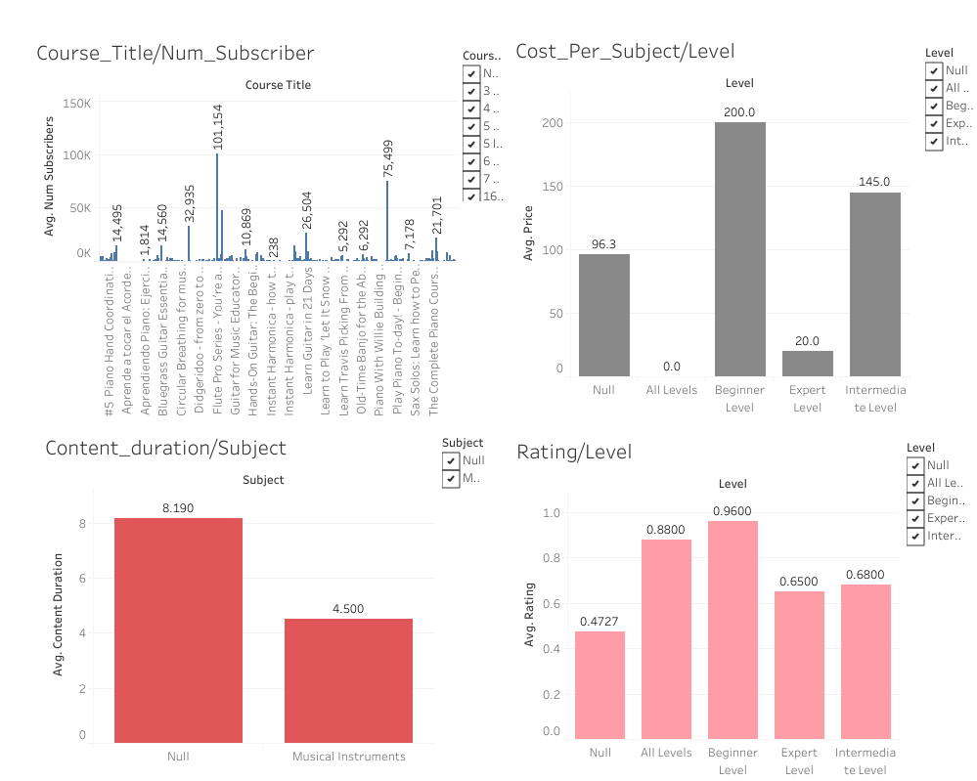

The following insight were derived and observed from the Udemy_Music_Courses Chart above:

* The average Num Subscriber is around 101,154 in numbers
* Beginner level has the highest figures when considering Cost Per Subject (Price).
* When considering average rating per subject for each level, Beginner level also has the highest rating.
* For Music Subjects, Average Content Duration is 4500.

**Figure 4:** Udemy_Web_Development_Course Chart:

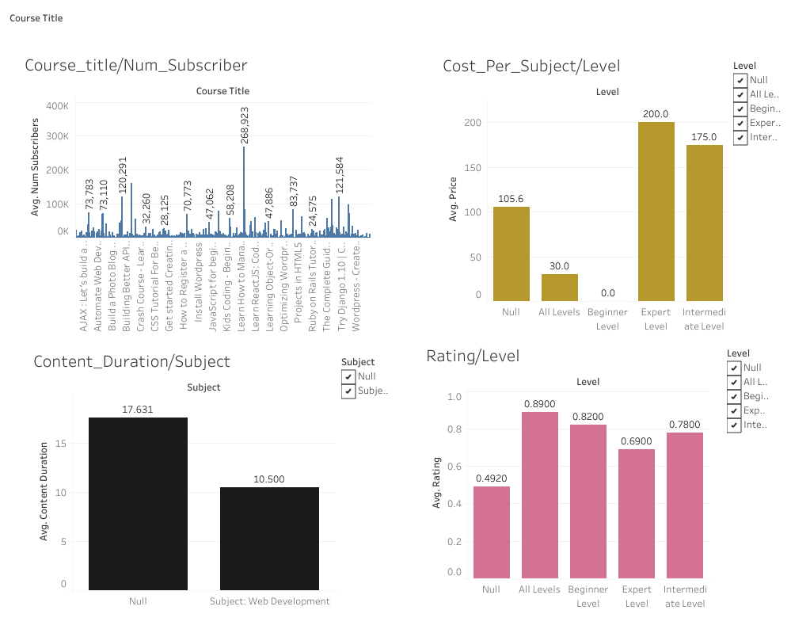

The following insight were derived and observed from the Udemy__Web_Development_Courses Chart above:

* The average Num Subscriber is around 268,923 in numbers
* Expert level and Intermediate level have the highest figures when considering Cost Per Subject (Price).
* When considering average rating per subject for each level, Beginner level and All levels have the highest rating.
* For Music Subjects, Average Content Duration is 10,500.

Looking through the Excel file to the last page where I inserted SUMMARY Pivot Table, we can find the SUM and AVERAGE for the comparison of all the Subjects with the number of people that subscribe to them. This was done through Copy and pasting on the page not VLOOKUP. The Table and Charts are shown below respectively:

**Table: 1:** Summary Table for Subjects / Sum Num_Subscribers

|  |  |
| --- | --- |
| *Subject* | SUM of Num Subscriber |
|  | 0 |
| Business | 1793822 |
| Design | 1028621 |
| Music | 820365 |
| Web Development | 7790403 |
| **Grand Total** |  |

**Figure 5:** SUM of Num Subscriber/ Subject

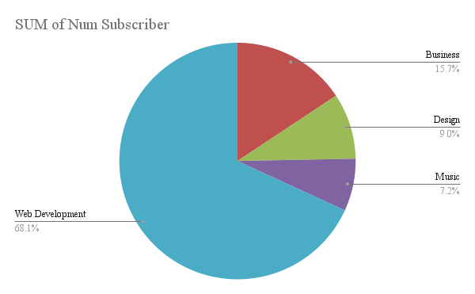

The table and the chart above show the total number of subscribers per each subjects and we can find out that Web Development with 68.1% has the highest number of subscribers follow by Business 15.7%, with Music 7.2% carrying the least.

**Table: 2:** Summary Table for Subject / Average Num_Subscribers

|  |  |
| --- | --- |
| *Subject* | *AVERAGE of Num Subscriber* |
|  | 0 |
| Business | 2203.712531 |
| Design | 2359.222477 |
| Music | 1943.992891 |
| Web Development | 7005.758094 |
| **Grand Total** |  |
|  |  |

**Figure 6:** AVERAGE of Num Subscriber/Subject

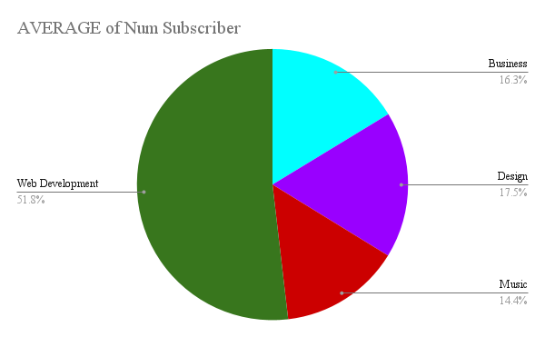

The table and the chart above show the Average number of subscribers per each subject with Web Development carrying the highest at 51.8% and Music 14.4% being the least.

**Analysis:**

Summary from all the 4 charts above depicts the following:

* Num Subscriber for Web Development are far more than other courses, next to it is the Music Courses.
* Beginner level courses are being patronized by people and will surely earn more money for Udemy than other remaining level courses.
* When rating the subjects, beginner level courses have the highest rating follow by All level courses.
* Among all the four courses, Web Development courses have the highest content duration.

However, looking into the 5 Why’s questions for this project, we can ask the following questions:

* Why is the revenue at Udemy decreasing? Because enough people are not subscribing to our courses and the popular courses they subscribed to, we are not charging enough money.
* Why are people not subscribing to our courses? Because we don't have enough popular courses.
* Why are we not having enough popular courses and why do we charge less for the one that we have? We charge less so as to attract many subscribers?
* Why are we not attracting many subscribers since we charge less? There is a problem with our courses.
* Why are we not resolving the problem with our courses and why can't we upgrade and update it so as to attract many customers? That question is the right the question!

**Conclusions:**

From the observation and insight gotten from the chart with the 5 Why’s questioning, I can conclude that Udemy should upgrade and update their beginner level Courses for all their 4 Categories: Business, Design, Music and Web Development.

Priority should be given to Web Development Courses because it commands highest numbers of subscribers and should be charged higher than other courses involved. This will surely lead to high patronage and increase company’s revenue.

For more details on Udemy_Courses_Olu project, kindly check the appendix of this project, you will find both my Excel link and Tableau link there to access more. It’s already shared for the public to access it.

**[World Population By Year] Project Description:**

The world population is the total number of humans currently living, and was estimated to have reached 7,794,798,739 people as of Year 2020. It took over 2 million years of human prehistory and history for the world's population to reach 1 billion and only 200 years more to grow to 7 billion.

The world population has experienced continuous growth following the Great Famine of 1315–1317 and the end of the Black Death in 1350, when it was near 370 million. This dramatic growth has been driven largely by increasing numbers of people surviving to reproductive age, and has been accompanied by major changes in fertility rates, increasing urbanization and accelerating migration.

These will have far-reaching implications for generations to come. In addition, the world is seeing high levels of urbanization and accelerating migration. People living in the rural areas are migrating fast to the urban areas and cities.

Population data is essential for planning purposes. Any country needs to know the size and composition of its population–around age and sex structure, among other factors. It helps countries to plan a lot for their present and future purposes.

This project will be narrowed down to World Population By Year from Year 1951 to 2020.

From the project topic, the business problem can be mentioned below as:

**“Yearly increase in urban population causing increase in World population.”**

The Dataset available to me has the following Variable which are:

Year: Ranges from 1951 to 2020.

Population: World Population

Change_Perc: Yearly Change in Percentage

Net_Change: Total Yearly Change

Density: Density is a measurement of population per unit area, or exceptionally unit volume. It is measured in P/Km²

Urban: Urban Population

Urban_Perc: Urban Population Percentage

Source of content: www.worldometers.info, Wikipedia, etc.

**Data Design:**

Removing duplicates and removing blank cells have been carried out on the World_Population_By_Year project, though other Data cleaning processes like clean up suggestion and column stats were also looked into on each data sheet.

Excel and Tableau are the two visualization tools that were used for this particular project; they show all the hidden insight and help our findings and observation on this particular project.

**Findings:**

Summarizing steps carried out so far and explaining the major noticeable findings below:

Getting the datasheet available from this project titled “World Population by year” with the following variables below:

Year: Ranges from 1951 to 2020.

Population: World Population

Change_Perc: Yearly Change in Percentage

Net_Change: Total Yearly Change

Density: It is measured in P/Km²

Urban: Urban Population

Urban_Perc: Urban Population Percentage

Source of content: www.worldometers.info,

Working with the data supplied on the Google Sheet, I was able to clean the data using “Remove Duplicate,” which deleted some numbers that exist in more than one times or were repeated. Blank cells were also removed too.

Under the Data visualization aspect, Excel Sheet and Tableau were both used to visualize the data so as to give us great insight and reliable observations. The tables were plot using pie chart, bar charts and some great charts from Tableau. I ensured that I stick with Average values of the Variables as done in the first project.

Insight and Observation from the chart are shown below:

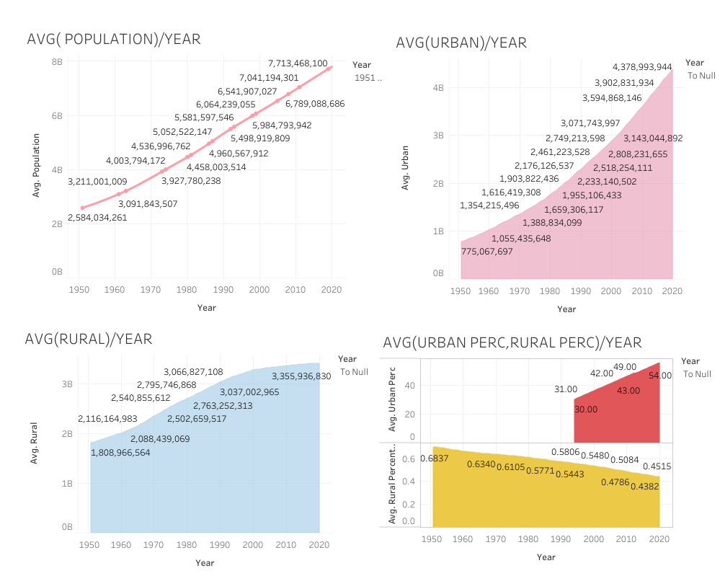

The following insight were derived and observed from the World_Population_By_Year Chart above:

* As the year increases from 1950 to 2020, The World population continue to increase with the highest being 7,713,468,100 as at 2020 from the chart above.
* Influx from Urban cities increase with the Urban population reaching 4,378,993,944. There is average population increase of over five hundred million from year 2000 to 2010 and 2010 to 2020 respectively.
* As year increases, Urban_Perc started to increase from year 2000 till 2020 whereas Rural_Percentage decreases from 1950 down till 2020.

**Data Analysis:**

Summary from the charts above depicts the following:

* As the year increases according to the ranges in this project shows that the World population continue to increase though the reason behind it was not specified within the scope of this dataset and project.
* Increment in the Urban population year in year out leads to the increase in the World Urban population and World Population in general.
* As year increases, Urban_Perc increases whereas Rural_Percentage decreases year in year out.
* With this rate that Urban Population are influencing World population yearly, we can project into the future with the insight that World population yearly will continue to rise year in year out.

However, looking into the 5 Why’s questions for this project, we can ask the following questions:

- Why is the increase in World population? This is because of increase in agriculture productivity, medical advancement and industrial revolution.

- Why is increase in industrial revolution and medical advancement causes increase in Urban population? Migration of people from rural region to urban region was as a result of opportunity available to them in the cities, urban areas worldwide.

- Why is Urban percentage of people increasing whereas Rural percentage decreasing though we have agricultural productivity coming majorly from the rural part of the world? Though there is increase in agricultural productivity, majority looks forward to the opportunities that the cities, Urban areas provide for them.

- Why is the rural population still on increase despite there is migration from Rural area to Urban areas? Since there is increase in agricultural productivity too, the rural population will fully enjoy this more than the Urban population.

- Why are we sure that the World population will continue to increase year in year out in the future? This is the right question and with all the available factors affecting the World population pointing towards that, we can agree that World population in the future will continue to rise.

**Conclusions:**

From the observations and insight gotten from the chart with the 5 Why’s questioning, I can conclude in this World_Population_By_year project with the dataset available, insight gotten and analysis carried out that:

With this rate that Urban Population are influencing World population yearly, we can project into the future with the insight that World population yearly will continue to rise year in year out.

Migration of people will not cease from rural areas to Urban areas and as Urban population is increasing worldwide, World population year in, year out will continue to be on the rise.

For more details on World_Population_By_Year project, kindly check the appendix of this project, you will find both my Excel link and Tableau link there to access more. It’s already shared for the public to access it.

**Appendix:**

**Excel:**

**Udemy_Courses_Olu:**

https://docs.google.com/spreadsheets/d/1PQ401tD_eGpp22tQvBJAYJHvVL2P48LBk0PdUUTpHtQ/edit?usp=sharing

**World_Population_By_Year:**

https://docs.google.com/spreadsheets/d/1EVtL3DM-Q9dmsHp0lKxSgejT-IrTDTx1hz0-p16hCJc/edit?usp=sharing

**Tableau:**

**Udemy Business Courses:**

https://public.tableau.com/views/Udemy_Business-Courses/Business_Dashboard?:language=en-US&:display_count=n&:origin=viz_share_link

**Udemy Design Courses:**

https://public.tableau.com/views/Tab_Udemy_Design_Courses/Design_Dashboard_1?:language=en-US&:display_count=n&:origin=viz_share_link

**Udemy Music Courses:**

https://public.tableau.com/views/Tab_Udemy_Music_Courses/Music_Dashboard?:language=en-US&:display_count=n&:origin=viz_share_link

**Udemy Web Design Courses:**

https://public.tableau.com/views/Tab_Udemy_Music_Courses/Music_Dashboard?:language=en-US&:display_count=n&:origin=viz_share_link

**World Population By Year:**

https://public.tableau.com/views/World_Population_By_Year/World_Population_Dashboard?:language=en-US&:display_count=n&:origin=viz_share_link